2019-2020

**Question 1 - Refer to Question 4 from 2017-18 for a large majority of this Q.**

**Does anyone know 3the answers? They are in that paper Thank you!**

a.i)

ii)

Iii)

b.i)

ii)

c.

d.

e.

f.i)

ii)

**Question 2 - Refer to Question 3 from 2018-19 for some of this Q**

a.

b.i)

ii)

c.i)

ii)

iii)

iv)

d.Intersection at (0,2,6)

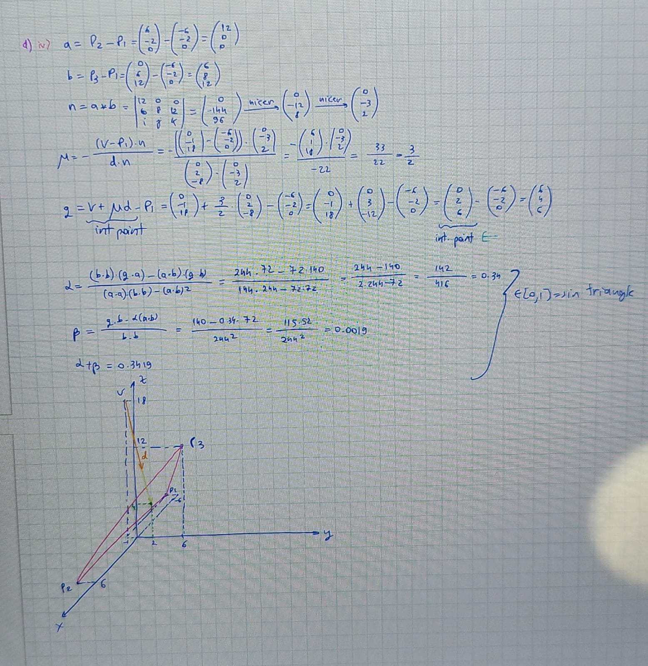

**Question 3**

a.

b.i)

ii)

iii)

iv)

c, d, e)

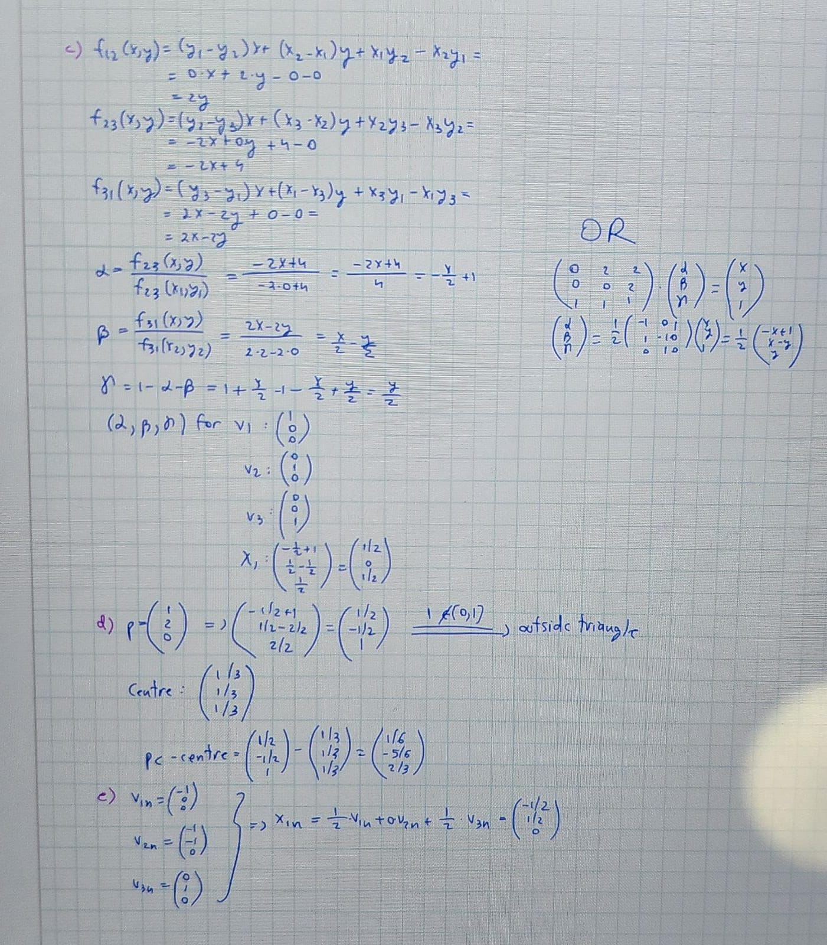

**Question 4**

a.i)

ii)

iii)

iv)

Refer to Question 1 from 2018-19

b.

c.i)

ii)

d.i)

ii)

iii)

iv)